Type-Safe Enumeration (Implementation Pattern)
- Direction.java - an enumeration type of directions: NORHT, EAST, SOUTH, and WEST
- Orientation.java - an enumeration type of orientations: HORIZONTAL and VERTICAL

Abstract Factory (Creational Pattern)
- The Maze game
  - Design
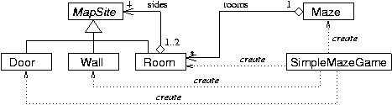
  - Implementation
    - MapSite.java - an interface for map sites in a maze game
      - Room.java - a room in a maze game, implements MapSite
      - Door.java - a door in a maze game, implements MapSite
      - Wall.java - a wall in a maze game, implements MapSite
    - Maze.java - a maze game
    - SimpleMazeGame.java - a simple implementation of the maze game that does not use creational patterns
      - Run the program as follows:
java maze.SimpleMazeGame
- create a small two-room Maze game [screen shot]
java maze.SimpleMazeGame Large
- create a large nine-room Maze game [screen shot]
      - Use the arrow keys to move the palyer.
- A design and implementation of the Maze game using Abstract Factory pattern
  - Desgin
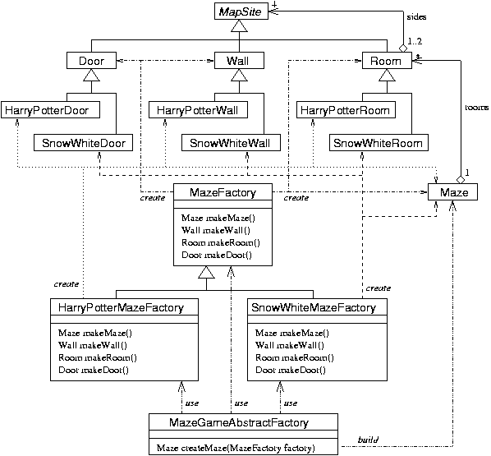
    - Separate views of the diagram for using each factory
      - Using HarryPotterMazeFactory
      - Using SnowWhiteMazeFactory
      - Using default MazeFactory
  - Implementation
    - Abstract factories
      - MazeFactory.java - a factory that creates default style rooms, doors, and walls for the Maze game
      - HarryPotterMazeFactory.java - a factory that creates "Harry Potter" style rooms, doors, and walls for the Maze game, extends MazeFactory
      - SnowWhiteMazeFactory.java - a factory that creates "Snow White" style rooms, doors, and walls for the Maze game, extends MazeFactory
    - Concrete products
      - HarryPotterRoom.java - a "HarryPotter" style room in the maze game, extends Room
      - HarryPotterDoor.java - a "HarryPotter" style door in the maze game, extends Door
      - HarryPotterWall.java - a "HarryPotter" style wall in the maze game, extends Wall
      - SnowWhiteRoom.java - a "SnowWhite" style room in the maze game, extends Room
      - SnowWhiteDoor.java - a "SnowWhite" style door in the maze game, extends Door
      - SnowWhiteWall.java - a "SnowWhite" style wall in the maze game, extends Wall
    - MazeGameAbstractFactory.java - an implementation of the maze game that uses the Abstract Factory pattern
      - Run the program as follows:
java maze.MazeGameAbstractFactory Harry
- create a "Harry Potter" style Maze game using the HarryPotterMazeFactory [screen shot]
java maze.MazeGameAbstractFactory Snow
- create a "Snow White" style Maze game using the SnowWhiteMazeFactory [screen shot]
java maze.MazeGameAbstractFactory
- create a default style Maze game using the default MazeFactory [screen shot]

Factory Method (Creational Pattern)
- Design
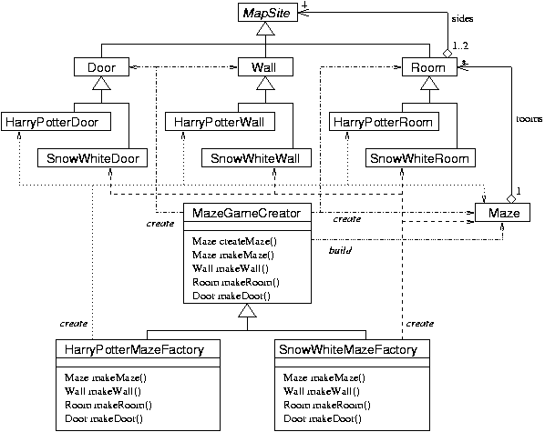
- Implementation
  - The maze creators
    - MazeGameCreator.java
    - HarryPotterMazeGameCreator.java
    - SnowWhiteMazeGameCreator.java
  - Run the program as follows:
java maze.MazeGameCreator Harry
- create a "Harry Potter" style Maze game using the HarryPotterMazeGameCreator [screen shot]
java maze.MazeGameCreator Snow
- create a "Snow White" style Maze game using the SnowWhiteMazeGameCreator [screen shot]
java maze.MazeGameCreator
- create a default style Maze game using the default MazeGameCreator [screen shot]

Prototype (Creational Pattern)
- Design
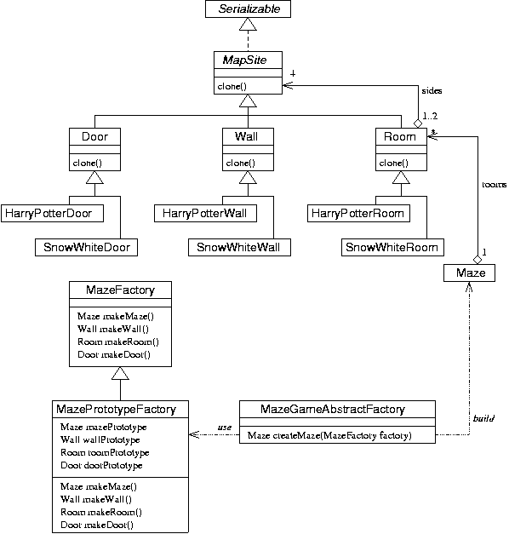
- Implementation
  - MazePrototypeFactory.java - An abstract factory for building maze game using Prototype design pattern
  - Run the program as follows:
java maze.MazePrototypeFactory Harry
- create a "Harry Potter" style Maze game using instances of HarryPotterDoor, HarryPotterRoom, and HarryPotterWall as prototypes [screen shot]
java maze.MazePrototypeFactory Snow
- create a "Snow White" style Maze game using instances of SnowWhiteDoor, SnowWhiteRoom, and SnowWhiteWall as prototypes [screen shot]
java maze.MazePrototypeFactory
- create a default style Maze game using instances of Door, Room, and Wall as prototypes [screen shot]
- A universal factory that uses Abstract Factory, Prototype and Singleton design patterns.
  - UniversalMazeFactory.java
  - It uses the following system properties to determine which factory will be used.
    - maze.prototype
      - "true "or "false": whether to use prototype based factory or not
    - maze.theme
      - "Harry", "Snow", or "Default": the theme used
  - Run the program as follows:
java -Dmaze.prototype=proto -Dmaze.theme=theme maze.MazeUniversalFactory
Note: the -D options must come before the class name.

Builder (Creational Pattern)
- Design
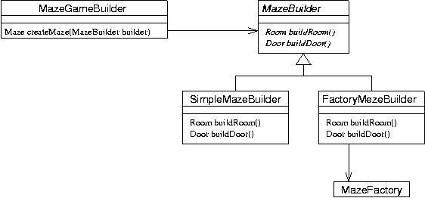
- Implementation
  - The maze builders
    - MazeBuilder.java - the interface
    - SimpleMazeBuilder.java - a simple maze builder
    - FactoryMazeBuilder.java - a maze builder using an abstract factory to create doors, rooms, and walls.
  - The driver class
    - MazeGameBuilder.java
    - Run the program as follows:
java maze.MazeGameBuilder Harry
- create a "Harry Potter" style Maze game using the FactoryMazeBuilder with HarryPotterMazeFactory [screen shot]
java maze.MazeGameBuilder Snow
- create a "Snow White" style Maze game using the FactoryMazeBuilder with SnowWhiteMazeFactory [screen shot]
java maze.MazeGameBuilder Default
- create a default style Maze game using the FactoryMazeBuilder with the default MazeFactory [screen shot]
java maze.MazeGameBuilder
- create a default style Maze game using the SimpleMazeBuilder [screen shot]

Command (Behavioral Pattern)
- Design
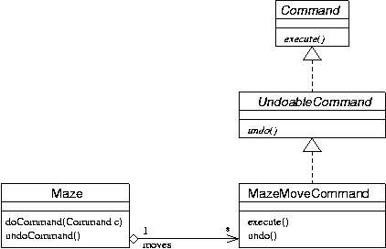
- Implementation
  - The commands
    - Command.java - the command interface
    - UndoableCommand.java - the interface for undoable command
    - MazeMoveCommand.java - the command class for make moves in the maze game
  - The driver class
    - UndoableMazeGame.java
    - Run the program as follows:
java maze.UndoableMazeGame Harry
- create a "Harry Potter" style undoable maze game using the FactoryMazeBuilder with HarryPotterMazeFactory [screen shot]
java maze.UndoableMazeGame Snow
- create a "Snow White" style undoable maze game using the FactoryMazeBuilder with SnowWhiteMazeFactory [screen shot]
java maze.UndoableMazeGame Default
- create a default style undoable maze game using the FactoryMazeBuilder with the default MazeFactory [screen shot]
java maze.UndoableMazeGame
- create a default style undoable maze game using the SimpleMazeBuilder [screen shot]

Adapter (Structural Pattern)
- Design
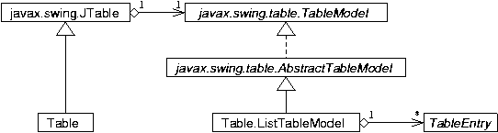
Adapter using inheritance
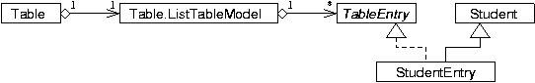
Adapter using deligation
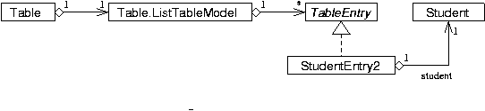
- Implementation
  - Table.java - a generic table
  - TableEntry.java - an interface for the entries to be displayed in the table, target of the adapter pattern
  - Student.java - the adaptee class
  - StudentEntry.java - an adapter using inheritance
  - StudentEntry2.java - an adapter using deligation
  - Main.java - the driver class
    - Run the program as follows: [screen shot]
java adapter.Main
- show a student table using an inheritance-based adapter, StudentEntry
java adapter.Main Deligation
- show a student table using a deligation-based adapter, StudentEntry2

Composite (Structural Pattern)
- Design
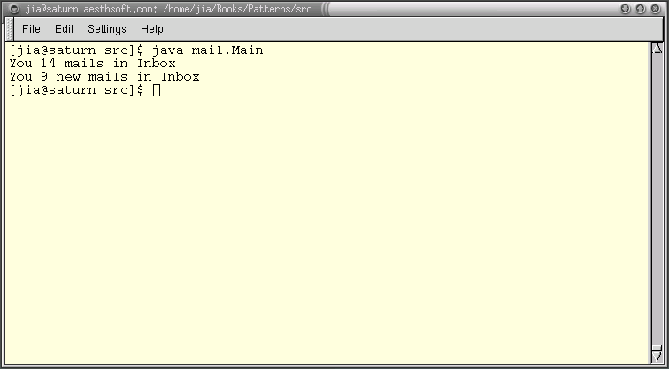
- Implementation
  - MailboxItem.java - the abstract component
  - MailFolder.java - a composite component
  - Mail.java - a leaf component
  - Two enumeration classes
    - MailPriority.java
    - MailStatus.java
  - Main.java - the driver class
  - Run the program as follows: [screen shot]
java mail.Main
- A GUI adaptation, using the Adapter pattern
  - Design
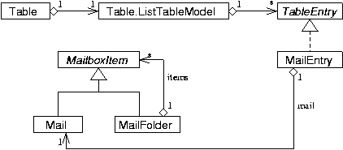
  - Implementation
    - gui/MailEntry.java -- an adapter, with the Mail class as the adaptee and the TableEntry class as the target
    - gui/Main.java - the driver class
      - Run the program as follows: [screen shot]
java mail.gui.Main

